caElmir- UCDavis

Test Plan

Document Change History
Version Number | Date | Contributor | Description
V1.0 |  |  | Initial document



Table of Contents

1 Introduction 4
1.1 Scope 4
1.1.1 In Scope 4
1.1.2 Out of Scope 4
1.2 Quality Objective 4
1.2.1 Primary Objective 4
1.2.2 Secondary Objective 5
1.3 Roles and Responsibilities 5
1.3.1 Developer 5
1.3.2 Adopter 5
1.3.3 Testing Process Management Team 5
1.4 Assumptions for Test Execution 6
1.5 Constraints for Test Execution 6
1.6 Definitions 7
2 Test Methodology 7
2.1 Purpose 7
2.1.1 Overview 7
2.1.2 Usability Testing 7
2.1.3 Unit Testing (Multiple) 7
2.1.4 Iteration/Regression Testing 8
2.1.5 Final release Testing 8
2.1.6 Testing completeness Criteria 8
2.2 Test Levels 8
2.2.1 Build Tests 8
2.2.1.1 Level 1 - Build Acceptance Tests 8
2.2.1.2 Level 2 - Smoke Tests 8
2.2.1.3 Level 2a - Bug Regression Testing 9
2.2.2 Milestone Tests 9
2.2.2.1 Level 3 - Critical Path Tests 9
2.2.3 Release Tests 9
2.2.3.1 Level 4 - Standard Tests 9
2.3 Use Acceptance Testing: 9
2.3.1 Adopter Team: 9
2.3.2 Acceptance Testing: 10
2.3.2.1 Objective: 10
2.3.2.2 Beta testing: 10
2.4 Bug Regression 10
2.5 Bug Triage 10
2.6 Suspension Criteria and Resumption Requirements 11
2.7 Test Completeness 11
2.7.1 Standard Conditions: 11
2.7.2 Bug Reporting & Triage Conditions: 11
3 Test Deliverables 11
3.1 Deliverables Matrix 12
3.2 Documents 13
3.2.1 Test Approach Document 13
3.2.2 Test Plan 13
3.2.3 Test Specifications 13
3.3 Defect Tracking & Debugging 13
3.3.1 Testing Workflow 13
3.3.2 Defect reporting using G FORGE 14
3.4 Reports 16
3.4.1 Testing status reports 16
3.4.2 Phase Completion Reports 16
3.4.3 Test Final Report - Sign-Off 16
3.5 Responsibility Matrix 16
4 Resource & Environment Needs 16
4.1 Testing Tools 17
4.1.1 Tracking Tools 17
4.1.1.1 Configuration Management 17
4.2 Test Environment 17
4.2.1 Hardware 17
4.2.2 Software 17
4.3 Bug Severity and Priority Definition 17
4.3.1 Severity List 18
4.3.2 Priority List 18
4.4 Bug Reporting 18
5 Terms/Acronyms 19

Introduction
This test approach document describes the appropriate strategies, process, workflows and methodologies used to plan, organize, execute and manage testing of software projects within caBIG.

Scope
This document will outline the functionality testing of caElmir using unit tests, and user acceptance testing. The goal of the testing is to verify that caElmir meets or exceeds the needs to our user base as well as the specifications outlined in the Specification and Requirments documentation.

In Scope
The caBIG ICR caELMIR Test Plan defines the unit, integration, system, regression, and Client Acceptance testing approach. The test scope includes the following:
- Testing of all functional, application performance, security and use cases requirements listed in the Use Case document.
- Quality requirements and fit metrics<system name>.
- End-to-end testing and testing of interfaces of all systems that interact with the <system name>.

Out of Scope
The following are considered out of scope for caBIG ICR caELMIR system Test Plan and testing scope:
- Functional requirements testing for systems outside caELMIR, such as colony management systems and pathology database systems
- Testing of Business SOPs, disaster recovery and Business Continuity Plan.

Quality Objective

Primary Objective
A primary objective of testing application systems is to: assure that the system meets the full requirements, including quality requirements (AKA: Non-functional requirements) and fit metrics for each quality requirement and satisfies the use case scenarios and maintain the quality of the product. At the end of the project development cycle, the user should find that the project has met or exceeded all of their expectations as detailed in the requirements.

Any changes, additions, or deletions to the requirements document, Functional Specification, or Design Specification will be documented and tested at the highest level of quality allowed within the remaining time of the project and within the ability of the test team.

Secondary Objective
The secondary objective of testing application systems will be to: identify and expose all issues and associated risks, communicate all known issues to the project team, and ensure that all issues are addressed in an appropriate matter before release. As an objective, this requires careful and methodical testing of the application to first ensure all areas of the system are scrutinized and, consequently, all issues (bugs) found are dealt with appropriately.

Roles and Responsibilities

Developer
An NCI-designated Cancer Center selected and funded by NCICB to participate in a specific Workspace to undertake software or solution development activities. Responsible to:
(a) Develop the system/application
(b) Develop Use cases and requirements in collaboration with the Adopters
(c) Conduct Unit, system, regression and integration testing
(d) Support user acceptance testing

Adopter
An NCI-designated Cancer Center selected and funded by NCICB to undertake formal adoption, testing, validation, and application of products or solutions developed by Workspace Developers. Responsible to:
(a) Contribute to Use case, requirement development through review
(b) Contribute to develop and execution of the development test scripts through review
(c) Conduct Full User Acceptance, regression, and end-to-end testing; this includes identifying testing scenarios, building the test scripts, executing scripts and reporting test results

Testing Process Management Team
The testing process management team include NCI, BAH and Cancer Center Leads allocated to the ICR, as well as MMHCC leads and caElmir developers. Group responsible to manage the entire testing process, workflow and quality management with activities and responsibilities to:

(a) Monitor and manage testing integrity and Support testing activities
(b) Coordinate activities across cancer centers
(c) Coordinate activities across MMHCC sites

Assumptions for Test Execution
- For User Acceptance testing, the Developer team has completed unit, system and integration testing and met all the Requirement’s (including quality requirements) based on Requirement Traceability Matrix.
- User Acceptance testing will be conducted by End-users
- Test results will be reported on daily basis using Gforge. Failed scripts and defect list from Gforge with evidence will be sent to Developer directly.
- Test scripts are developed and approved.
- Test Team will support and provide appropriate guidance to Adopters and Developers to conduct testing
- Major dependencies should be reported immediately after the testing kickoff meeting.

Constraints for Test Execution

- Adopters should clearly understand on test procedures and recording a defect or enhancement. Testing Process Management Team will schedule a teleconference with Developers and Adopters to train and address any testing related issues.
- Developer will receive consolidated list of request for test environment set up, user accounts set up, data set (actual and mock data), defect list, etc. through GForge after the initial Adopter testing kick off meeting.
- Developer will support ongoing testing activities based on priorities
- Test scripts must be approved by Test Lead prior test execution
- Test scripts must test legacy database integration (colony management system, and pathology middle ware)
- The Developer cannot execute the User Acceptance and End to End test scripts. After debugging, the developer can conduct their internal test, but no results from that test can be recorded / reported.
- Adopters are responsible to identify dependencies between test scripts and submit clear request to set up test environment

Definitions
Bugs: Any error or defect that cause the software/application or hardware to malfunction. That is also included in the requirements and does not meet the required workflow, process or function point.

Enhancement:
1) Any alteration or modification to the existing system for better workflow and process.
2) An error or defect that causes the software/application or hardware to malfunction.
Where 1) and 2) is NOT included in the requirements can be categorized as an enhancement.

Enhancement can be added as a new requirement after appropriate Change Management process.

Test Methodology

Purpose

Overview
The purpose of the Test Plan is to achieve the following:
- Define testing strategies for each area and sub-area to include all the functional and quality (non-functional) requirements.
- Divide Design Spec into testable areas and sub-areas (do not confuse with more detailed test spec). Be sure to also identify and include areas that are to be omitted (not tested) also.
- Define bug-tracking procedures.
- Identify testing risks.
- Identify required resources and related information.
- Provide testing Schedule.

Usability Testing
The purpose of usability testing is to ensure that the new components and features will function in a manner that is acceptable to the customer.
Development will typically create prototype UI components to evaluate the proposed design. Usability testing can be coordinated by testing, but actual testing must be performed by non-testers (as close to end-users as possible). Testing will review the findings and provide the project team with its evaluation of the impact these changes will have on the testing process and to the project as a whole.

Unit Testing (Multiple)
Unit Testing is conducted by the Developer during code development process to ensure that proper functionality and code coverage have been achieved by each developer both during coding and in preparation for acceptance into iterations testing.

CaElmir must pass all unit “Test Cases” as described on the “Test management Tool” website (http://tmt.persistent.co.in:9000/caelmirtmt/ManageTmtAdmin.do).

Iteration/Regression Testing
All level 1 and level 2 bugs identified during iterative development cycles must be verified as fixed prior to entering beta and acceptance testing. In addition prior to acceptance into Final Release testing the following will be available:
- Installation instructions
- All documentation (beta test scripts, manuals or training guides, etc.)

Final release Testing
Assuming critical bugs are resolved during previous iterations testing- Throughout the Final Release test cycle, bug fixes will be focused on minor and trivial bugs (severity 3 and 4). Testing will continue its process of verifying the stability of the application through regression testing (existing known bugs, as well as existing test cases).

The milestone target of this phase is to establish that the application under test has reached a level of stability, appropriate for its usage (number users, etc.), that it can be released to the end users and caBIG community.

Testing completeness Criteria

The milestone target is to place the release/app (build) into production after it has been shown that the app has reached a level of stability that meets or exceeds the client expectations as defined in the Requirements, Functional Spec., and caBIG Production Standards.

Test Levels
The test categories and test levels are defined below:

Build Tests

Level 1 - Build Acceptance Tests
The application will be built and deployed on two separate Windows 2003 servers to test both the Oracle specific build scripts as well as the PostgreSQL build scripts. If the application builds successfully on both platforms then the other tests may proceed. If caElmir fails to build on either the Oracle or PostgreSQL server then the application will be returned to the developer team and further tests will be postponed until the build is successful.

Level 2 - Smoke Tests
All caElmir main functionality will be tested utilizing automatic scripts. Should any of the main functions fail the build will be returned to the developer team and further testing will be postponed until the build is successful. Testing will consist of automated scrips and test the components listed below:
Administrative Data module
Audit Module
Disable data module
Experimental Data module
Manage Experiments module
Manage Protocols module
Publish data module
Data Query module
User Management module
Please refer to http://tmt.persistent.co.in:9000/caelmirtmt/ManageTmtAdmin.do for details.

Level 2a - Bug Regression Testing
All previously fixed bugs will be verified as fixed, or regressed. If a bug resurfaces as being a bug it will be logged back into the developers bug tracking system for repair.

Milestone Tests

Level 3 - Critical Path Tests
Critical path tests will focus on testing the core functionality of caElmir. Specifically the tests will focus on the being able to accomplish the core tasks as outlined in the use-case docuemtation. Specifically the developers will test the ability to:
create a study
create an experiment
create a protocol
assign a protocol to a study and an experiment
create a cohort
assign experimental animals to a cohort
assign a cohort to an experiment
add experimental data
Please refer to http://tmt.persistent.co.in:9000/caelmirtmt/ManageTmtAdmin.do for details.

Release Tests

Level 4 - Standard Tests
Standard tests will be carried out for each build cycle. Should any of the standard tests fail, the build will be postponed until the tests pass. The tests include:
Build deployment on both Oracle 10G and PostgreSQL 8X
Verify all GUI elements
Verity data base integrity with test data

Use Acceptance Testing:

Adopter Team:
Adopters for caElmir consist of two main groups. The first is the Mutant mouse pathology Lab at UCDavis, and the second consists of Mutant Mouse of Human Cancer consortium (MMHCC) sponsored users who will be testing the system by entering initial Rapamycin pre-clinical drug trial experimental data into caElmir. Adopters will conduct the following testing phase

Acceptance Testing:
This is typically used as a mechanism to handover the system to the customer. Adopters of the caElmir System will perform acceptance testing from user point of view. This phase of testing assures that the end product meets or does not meet the expectations as detailed in the requirements.

Objective:
The objective of the testing is to assure that the end product meet or does not meet the expectations as detailed in the requirements.

Beta testing:
caElmir adopters will test all the core functional of the system by imputing data form the MMHCC Rapamycine pre-clinical drug trials. Feedback will be in the form of bug reports logged into the caElmir Gforge website. All bugs will be reviewed by the caElmir lead and sorted into bugs and feature requests. Bugs will be forwarded to the development team and logged into the development team bugzilla application. Feature requests will be noted and used to develop additional use cases for later continued development and improvement. At a minimum beta testers will test the following functionality by entering data directly into the application:
- Study creation
- Dynamic entry creation
- Protocol creation and association with a study and experiment
- Cohort creation, and association with an experiment
- Assignment of animals to a cohort
- Colony management integration
- Experiment creation
- Experimental data entry

Bug Regression
All bugs that are resolved as “Fixed, Needs Re-Testing” will be regressed when Testing team is notified of the new drop containing the fixes. When a bug passes regression it will be considered “Closed, Fixed”. If a bug fails regression, adopters testing team will notify development team by entering notes into GForge. When a Severity 1 bug fails regression, adopters Testing team should also put out an immediate email to development. The Test Lead will be responsible for tracking and reporting to development and product management the status of regression testing.

Bug Triage

Bug Triage will be discussed at the weekly development meetings with participation form the Test Lead, and Development Lead, or their designator. The Test Lead will provide required documentation and reports on bugs for all attendees, usually by submitting reports to the development bugzilla site directly. When bugs are identified by one of beta testers and logged into the Gforge site, that documentation will function as the the bug report. The purpose of the triage is to determine the type of resolution for each bug and to prioritize and determine a schedule for all “To Be Fixed Bugs’. Development will then assign the bugs to the appropriate person for fixing and report the resolution of each bug back into bugzilla or GForge bug tracker system. The Test Lead will be responsible for tracking and reporting on the status of all bug resolutions.

Suspension Criteria and Resumption Requirements
Should caElmir fail Level 1 or 2 testing on three iterations, then all further testing will be suspended until the level 1 or 2 issue can be resolved. Once the issue is resolved the bug will be regressed and formal testing will resume once regression has passed.
In addition to critical level test failure, if there is a significant change in scope, which would interrupt down stream testing, testing will be stopped until the deployment of the new component.

Test Completeness
Testing will be considered complete when the following conditions have been met:

Standard Conditions:
- When Adopters and Developers, agree that testing is complete, the app is stable, and agree that the application meets functional requirements.
- Script execution of all test cases in all areas have passed.
- Automated test cases have in all areas have passed.
- All priority 1 and 2 bugs have been resolved and closed.
- NCI approves the test completion
- Each test area has been signed off as completed by the Test Lead.
- 50% of all resolved severity 1 and 2 bugs have been successfully re-regressed as final validation.
- Ad hoc testing in all areas has been completed.

Bug Reporting & Triage Conditions:
Bug status reports will consist of:
- Bug find rate indicates a decreasing trend prior to Zero Bug Rate (no new Sev. 1/2/3 bugs found).
- Bug find rate remains at 0 new bugs found (Severity 1/2/3) despite a constant test effort across 3 or more days.
- Bug severity distribution has changed to a steady decrease in Sev. 1 and 2 bugs discovered.
- No ‘Must Fix’ bugs remaining prior despite sustained testing.

Test Deliverables
Testing will provide specific deliverables during the project. These deliverables fall into three basic categories: Documents, Test Cases / Bug Write-ups, and Reports. Here is a diagram indicating the dependencies of the various deliverables:

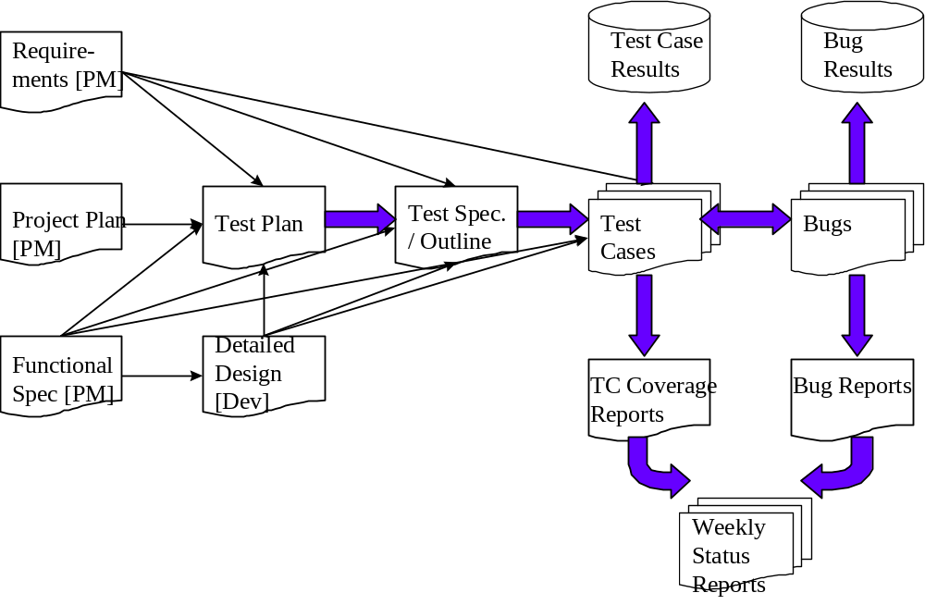

As the diagram above shows, there is a progression from one deliverable to the next. Each deliverable has its own dependencies, without which it is not possible to fully complete the deliverable.

The following page contains a matrix depicting all of the deliverables that Testing will use.

Deliverables Matrix

Deliverable
Documents
Test Approach
→ Test Plan
→ Test Schedule
→ Test Specifications
Test Case / Bug Write-Ups
Test Cases / Results
Test Coverage Reports
GForge Bug tracker for bug reporting
Reports
Test results report
Test Final Report - Sign-Off

Documents

Test Approach Document
When this document is completed, the Test Lead will distribute it to the Product Manager, Development Lead, User Representative, Program Manager, and others as needed for review and sign-off.

Test Plan
The purpose of the Test Plan document is to:
- Specify the approach that Testing will use to test the product, and the deliverables (extract from the Test Approach).
- Break the product down into distinct areas and identify features of the product that are to be tested.
- Specify the procedures to be used for testing sign-off and product release.
- Indicate the tools used to test the product.
- List the resource and scheduling plans.
- Indicate the contact persons responsible for various areas of the project.
- Identify risks and contingency plans that may impact the testing of the product.
- Specify bug management procedures for the project.
- Specify criteria for acceptance of development drops to testing (of builds).

Test Specifications
A Test Specification document is derived from the Test Plan as well as the Requirements, Functional Spec., and Design Spec documents. It provides specifications for the construction of Test Cases and includes list(s) of test case areas and test objectives for each of the components to be tested as identified in the project’s Test Plan.

Defect Tracking & Debugging

Testing Workflow
The below workflow illustrates the testing workflow process for Developers and Adopters for User Acceptance and End to End testing.
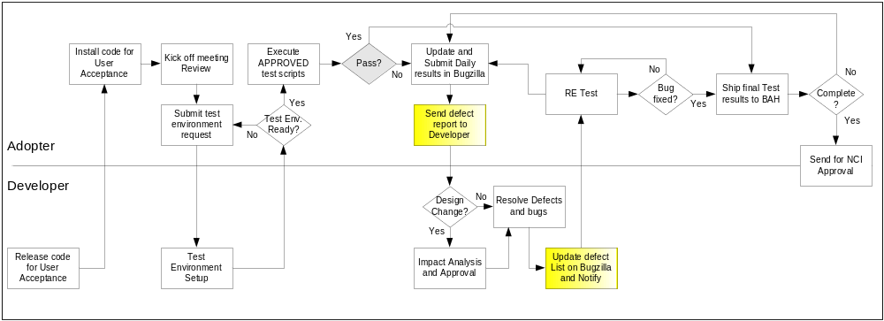

Defect reporting using G FORGE
ALL defects should be logged using ‘G FORGE’, to address and debug defects. Adopters are also requested to send a daily defect report to the developer. Developers will update the defect list on G Forge and notify the requestor after the defect has been resolved.
Developers and Adopters are required to request an account on G Forge for the relative workspace. Debugging should be based on Priority – High > Medium > Low, these priorities are set by the Adopters and are based on how critical is the test script in terms of dependency and mainly based on use case scenario.
Below screen shot displays ‘Add new Defect’ screen, fields marked with ( * ) are mandatory fields and Adopters should also upload the evidence file for all the defects listed.

All High priority defects should be addressed within 1 day of the request and resolved/closed within 2 days of the initial request
All Medium priority defects should be addressed within 2 days of the request and resolved/closed within 4 days of the initial request
All Low priority defects should be resolved/closed no later than 5 days of the initial request.

G Forge URL - http://gforge.nci.nih.gov
User may either search for workspace or select from list of recent project from the bottom right side of the window. E.g. searching for ‘caties’.
At the workspace, the user can request Administrators to setup their user account for that workspace.
After login, user can select ‘Tracker’ tab to ‘Submit New’ defect. User can add defect info. As shown in below screen.

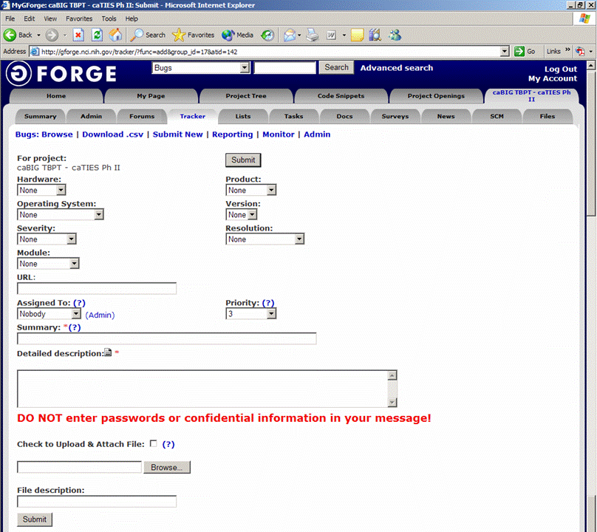
Field Comments
Hardware - List the testing environment hardware. e.g. PC, MAC
Product - Add default to workspace name e.g. caTIES
Operating System - Win 98, Win 2k, Win XP, MAC, etc.
Version - Application version
Severity - If it is an enhancement or a bug with minor to major severity that may not interfere with further testing or completely block any future testing efforts.
Resolution - Only DEVELOPER will update based on the defect
Module - For an application with multiple modules, select appropriate module for the defect reported.
URL - Add URL if any
Assigned to - To be updated by Developer, for whom the ticket is assigned to
Priority - Set a priority based on severity
Summary - Summary of the defect, bug or issue
Detailed Desc. - Details of the defect, bug or issue
Upload file - Attach evidence file
Submit - Submit the bug ticket

Reports
The Test Lead will be responsible for writing and disseminating the following reports to appropriate project personnel as required.

Testing status reports
A weekly or bi-weekly status report will be provided by the Test Lead to project personnel. This report will summarize weekly testing activities, issues, risks, bug counts, test case coverage, and other relevant metrics.

Phase Completion Reports
When each phase of testing is completed, the Test Lead will distribute a Phase Completion Report to the Product manager, Development Lead, and Program Manager for review and sign-off.
The document must contain the following metrics:
- Total Test Cases, Number Executed, Number Passes / Fails, Number Yet to Execute
- Number of Bugs Found to Date, Number Resolved, and Number still Open
- Breakdown of Bugs by Severity / Priority Matrix
- Discussion of Unresolved Risks
- Discussion of Schedule Progress (are we where we are supposed to be?)

Test Final Report - Sign-Off
A Final Test Report will be issued by the Test Lead. It will certify as to the extent to which testing has actually completed (test case coverage report suggested), and an assessment of the product’s readiness for Release to Production.

Responsibility Matrix
The following individuals will be responsible for initial caElmir testing and deployment:
Name | Title | Responsibilities
Jose Galvez, MD | PI at UCD | Privatization, project approval, design approval, Test Lead
Sumit Deshmukh | Developer Project lead | Development resource allocation
Sandeep Chinta | Developer | Application development and bug resolution
Clancy Miller | Adopter UCD | Data entry
Kate Yen | Adopter, MMHCC | Data entry

Resource & Environment Needs

Testing Tools

Tracking Tools
GForge bug tracker is used by caBIG to enter and track all bugs and project issues. The Test Lead is responsible for maintaining the GForge database.

Configuration Management
The project lead will login to Gforge weekly and update the database as needed to insure that it is up to date.

Test Environment

Hardware
Testing will be accomplish on the following minimal hardware:
Server side:
CPU 2 Ghz
Ram 2GB

Client side:
Windows Configuration:
Operating system: Windows XP Service Pack 2
CPU 2 Ghz
Ram 1GB
Mac Configuration:
Operating system OSX 10.
CPU G4
Ram 1GB

Software
In addition to the application and any other customer specified software, the following list of software should be considered a minimum
- Windows XP, Windows 2003 Server
- Macintosh OSX 10.14
- Oracle 10g
- PostgreSQL 8.14
- Jboss 4.0.0
- Internet explorer 6.0
- Firefox 2.0
- JRE 1.4

Bug Severity and Priority Definition
Bug Severity and Priority fields are both very important for categorizing bugs and prioritizing if and when the bugs will be fixed. The bug Severity and Priority levels will be defined as outlined in the following tables below. Testing will assign a severity level to all bugs. The Test Lead will be responsible to see that a correct severity level is assigned to each bug.

The Test Lead, Development Lead and Program Manager will participate in bug review meetings to assign the priority of all currently active bugs. This meeting will be known as “Bug Triage Meetings”. The Test Lead is responsible for setting up these meetings on a routine basis to address the current set of new and existing but unresolved bugs.

Severity List
The tester entering a bug into GForge is also responsible for entering the bug Severity.

Severity ID | Severity Level | Severity Description
1 | Critical | The module/product crashes or the bug causes non-recoverable conditions. System crashes, GP Faults, or database or file corruption, or potential data loss, program hangs requiring reboot are all examples of a Sev. 1 bug.
2 | High | Major system component unusable due to failure or incorrect functionality. Sev. 2 bugs cause serious problems such as a lack of functionality, or insufficient or unclear error messages that can have a major impact to the user, prevents other areas of the app from being tested, etc. Sev. 2 bugs can have a work around, but the work around is inconvenient or difficult.
3 | Medium | Incorrect functionality of component or process. There is a simple work around for the bug if it is Sev. 3.
4 | Minor | Documentation errors or signed off severity 3 bugs.

Priority List
Priority ID | Priority Level | Priority Description
5 | Must Fix | This bug must be fixed immediately; the product cannot ship with this bug.
4 | Should Fix | These are important problems that should be fixed as soon as possible. It would be an embarrassment to the company if this bug shipped.
3 | Fix When Have Time | The problem should be fixed within the time available. If the bug does not delay shipping date, then fix it.
2 | Low Priority | It is not important (at this time) that these bugs be addressed. Fix these bugs after all other bugs have been fixed.
1 | Trivial | Enhancements/ Good to have features incorporated- just are out of the current scope.

Bug Reporting
Testing team recognizes that the bug reporting process is a critical communication tool within the testing process. Without effective communication of bug information and other issues, the development and release process will be negatively impacted.

The Test Lead will be responsible for managing the bug reporting process. Testing’s standard bug reporting tools and processes will be used. GForge is the company-wide standard Bug Logging / Tracking tool. Testing and development will enter their data into the GForge database following the field entry definitions defined below.

Terms/Acronyms
TERM/ACRONYM | DEFINITION
API | Application Program Interface
BAH | Booz Allen Hamilton
BCP | Business Continuity Plan
CAT | Client Acceptance Testing
End-to End Testing | Tests user scenarios and various path conditions by verifying that the system runs and performs tasks accurately with the same set of data from beginning to end, as intended.
ER;ES | Electronic Records; Electronic Signatures
N/A | Not Applicable
NCI | National Cancer Institute
QA | Quality Assurance
RTM | Requirements Traceability Matrix
SME | Subject Matter Expert
SOP | Standard Operating Procedure
TBPT | Tissue Bank and Pathology Tools
TBD | To Be Determined
TSR | Test Summary Report
TMT | Test Management Tool
MMHCC | Mouse Modles of Human Cancer consortium
UCD | University of California, Davis

